🔐 PortSwigger Lab: File Path Traversal – Traversal Sequences Blocked with Absolute Path Bypass

🧪 Lab Overview
Lab Name: File path traversal, traversal sequences blocked with absolute path bypass
Difficulty: Practitioner
Status: Solved
Vulnerability Type: File Path Traversal
This lab contains a path traversal vulnerability in the functionality used to display product images.
The application blocks traditional path traversal sequences such as:
../../../etc/passwd
However, it accepts an absolute file path.
The objective of the lab was to retrieve the contents of:
/etc/passwd

🧠 How I Approached the Problem
I started by accessing the lab and exploring the application.
Since the vulnerability was related to product images, I opened one of the product images in a new tab to identify how the application requested the image from the server.
I found a URL containing a filename parameter similar to:
/image?filename=8.jpg
This indicated that the application was using the filename parameter to retrieve files from the server.
I then enabled FoxyProxy to route the browser traffic through Burp Suite and captured the request.
First, I tested a traditional path traversal payload:
../../../../../../etc/passwd
However, the server returned:
400 Bad Request
This showed that traversal sequences were being blocked.
Based on the lab description, I then tried using an absolute path:
/etc/passwd
The server successfully returned the contents of the /etc/passwd file, confirming the vulnerability and solving the lab.

📸 Screenshot-by-Screenshot Explanation
Screenshot 1: Lab Description
This screenshot shows the lab:
File path traversal, traversal sequences blocked with absolute path bypass
The lab description explains that the application is vulnerable through the product image functionality.
Although the application blocks normal traversal sequences, it may still be possible to access files using an absolute path.
The objective is to retrieve:
/etc/passwd
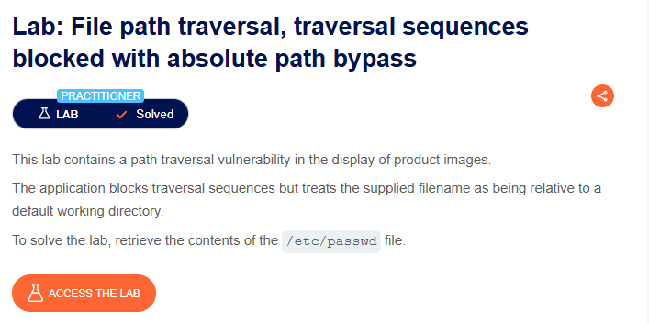
Screenshot 2: Accessing the Lab
After clicking Access the Lab, the application's home page opened.
The application displayed several products with images.
Since the lab description mentioned that the vulnerability existed in the display of product images, I focused on understanding how the images were being loaded from the server.

Screenshot 3: Opening a Product Image
To identify the endpoint responsible for retrieving product images, I right-clicked on one of the product images.
I selected:
Open image in new tab
This opened the image directly and allowed me to inspect the URL used to retrieve the image.

Screenshot 4: Identifying the filename Parameter
After opening the image in a new tab, I observed a URL similar to:
/image?filename=8.jpg
The filename parameter appeared to control which file was retrieved from the server.
Since user-controlled file parameters can sometimes be vulnerable to path traversal, I decided to test this parameter.
Before testing, I enabled FoxyProxy so that the browser traffic would be routed through Burp Suite.
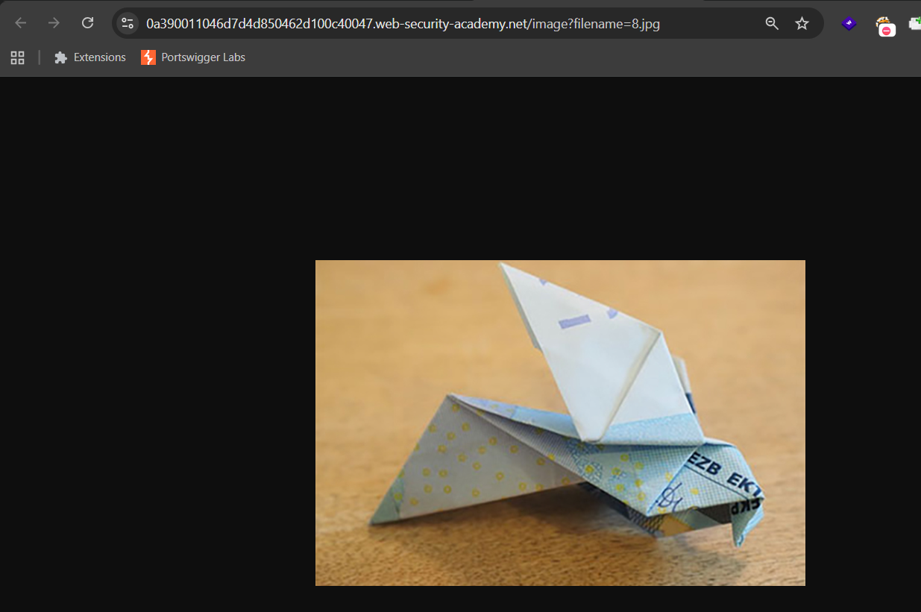
Screenshot 5: Testing Traditional Path Traversal
In Burp Suite, I first confirmed that the request was being sent to the correct lab host.
I then modified the filename parameter and tested a traditional path traversal payload:
filename=../../../../../../etc/passwd
After clicking Send, the server returned:
400 Bad Request
This indicated that the application was blocking traversal sequences such as ../.
Based on the lab description, I then considered using an absolute path instead of traversal sequences.
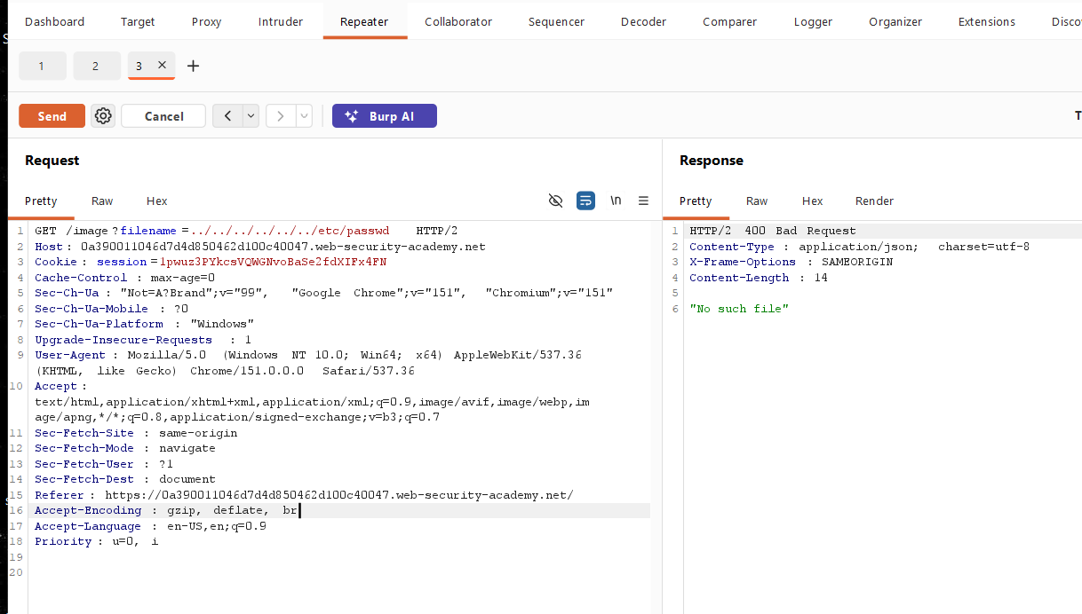
Screenshot 6: Testing the Absolute Path Bypass
I replaced the filename value with:
/etc/passwd
The request was similar to:
/image?filename=/etc/passwd
After clicking Send, the server returned the contents of the /etc/passwd file.
This confirmed that although the application blocked traditional traversal sequences, it did not properly restrict absolute file paths.
The lab was successfully solved.
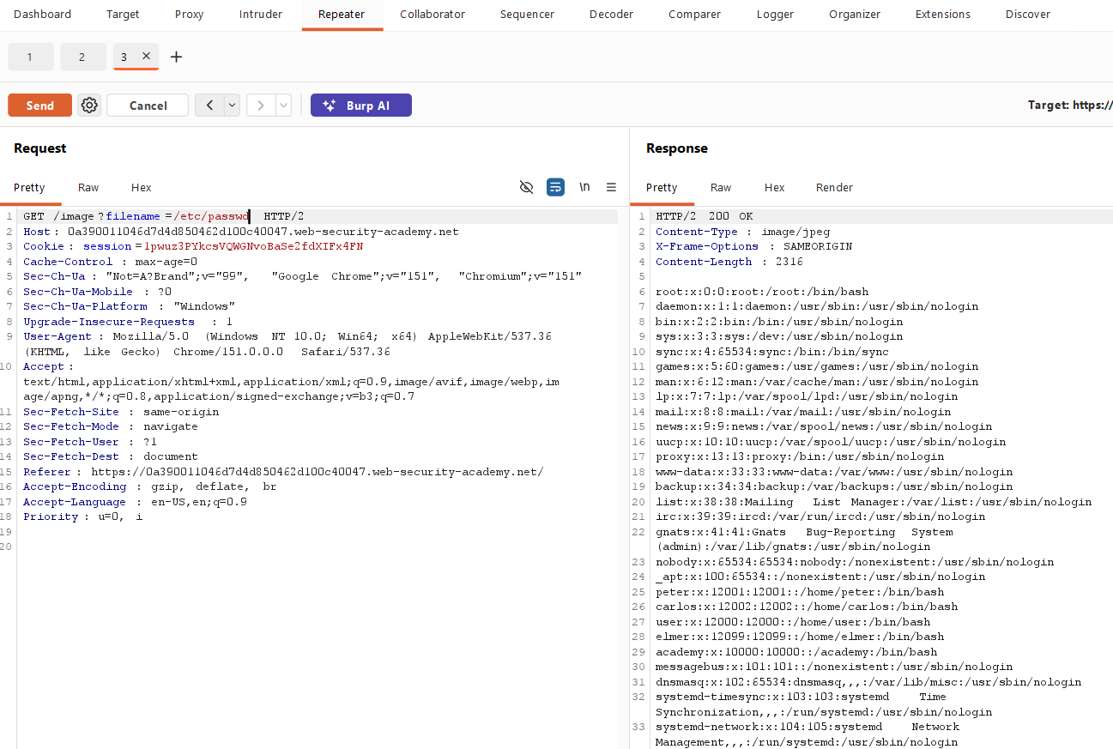
🔍 Different Possibilities I Considered
During the lab, I considered the following approaches:
- Identifying the endpoint used to retrieve product images.
- Inspecting the filename parameter.
- Testing traditional path traversal sequences using ../.
- Observing the server response.
- Trying an absolute file path.
- Requesting the /etc/passwd file directly.
The successful approach was using the absolute path:
/etc/passwd

⚡ How the Vulnerability Was Confirmed
The vulnerability was confirmed when the following payload successfully returned the contents of a sensitive system file:
filename=/etc/passwd
The traditional payload:
filename=../../../../../../etc/passwd
was blocked.
However, directly supplying the absolute path bypassed the application's filtering.
This demonstrated that the application did not properly validate the file path supplied through the filename parameter.

🎯 Root Cause
The root cause was insufficient server-side validation of user-controlled file paths.
The application attempted to block traversal sequences such as:
../
However, blocking only specific patterns is not sufficient.
The application still accepted absolute paths such as:
/etc/passwd
As a result, an attacker could potentially access files outside the intended directory.

🛡️ Remediation
1. Use an Allowlist of Files
Instead of accepting arbitrary file paths, the application should allow access only to predefined files.
For example:
product-image-1.jpg
product-image-2.jpg
product-image-3.jpg
2. Avoid Using User Input Directly in File Paths
User-controlled input should not be directly used to construct server-side file paths.
The application should map user input to safe, predefined resources.
3. Validate and Normalize File Paths
The application should validate the final resolved file path before accessing the file.
The resolved path should always remain inside the intended directory.
4. Block Access Outside the Intended Directory
The server should ensure that requested files cannot access sensitive system locations such as:
/etc/
or other directories outside the application's allowed file storage location.
📚 Key Learning
Through this lab, I learned that:
- File path traversal can occur when user input controls a server-side file path.
- Blocking only ../ is not sufficient protection.
- Absolute paths can sometimes bypass weak traversal filters.
- User input should never be directly trusted when accessing files.
- Server-side path validation is essential.
- Burp Suite can be used to capture and modify requests during authorized testing.
- Different payload variations may produce different server responses.
🎓 My Biggest Takeaway
Blocking one malicious pattern does not mean the application is secure.
In this lab, the application successfully blocked:
../../../etc/passwd
But it still accepted:
/etc/passwd
This demonstrates why security controls should focus on properly validating and restricting user input instead of simply blocking known malicious strings.
🏁 Conclusion
In this lab, I successfully exploited a file path traversal vulnerability using an absolute path bypass.
I started by identifying how product images were retrieved from the server and found a user-controlled filename parameter.
I first tested a traditional traversal payload, but it was blocked with a 400 Bad Request response.
I then tested an absolute path:
/etc/passwd
The server returned the contents of the requested file, confirming the vulnerability.
This lab demonstrated that blocking traversal sequences alone is not enough. Applications must properly validate file paths and restrict file access to authorized directories.

🧠 Learning Summary
Category | Details
Lab Name | File path traversal, traversal sequences blocked with absolute path bypass
Difficulty | Practitioner
Vulnerability Type | File Path Traversal
Affected Functionality | Product image display
Parameter Tested | filename
Traditional Payload | ../../../../../../etc/passwd
Traditional Payload Result | 400 Bad Request
Successful Payload | /etc/passwd
Bypass Technique | Absolute Path
Testing Tool | Burp Suite
Proxy Tool | FoxyProxy
Lab Objective | Retrieve /etc/passwd
Result | Successfully Solved

🔐 Vulnerability Type
File Path Traversal
File path traversal, also known as directory traversal, occurs when an application allows user-controlled input to access files outside the intended directory.
A vulnerable application may allow attackers to manipulate a file parameter.
For example:
filename=../../../etc/passwd
Even when traversal sequences are blocked, weak validation may still allow alternative bypasses, such as absolute paths:
filename=/etc/passwd
In this lab, the application blocked traditional traversal sequences but accepted an absolute path, allowing access to the /etc/passwd file.

